SERVICE ENGINEER CALL FLOW

Service coordinator do the following steps

URL- <https://mcis.deltaiserve.net/>

1)Type the URL , enter the login credential and do the login

Go to service job management and see the assigned service call

Go to action and click and see the actions available

Click assign and see the assignee list

Select the engineer name and submit ,service job assigned successfully.

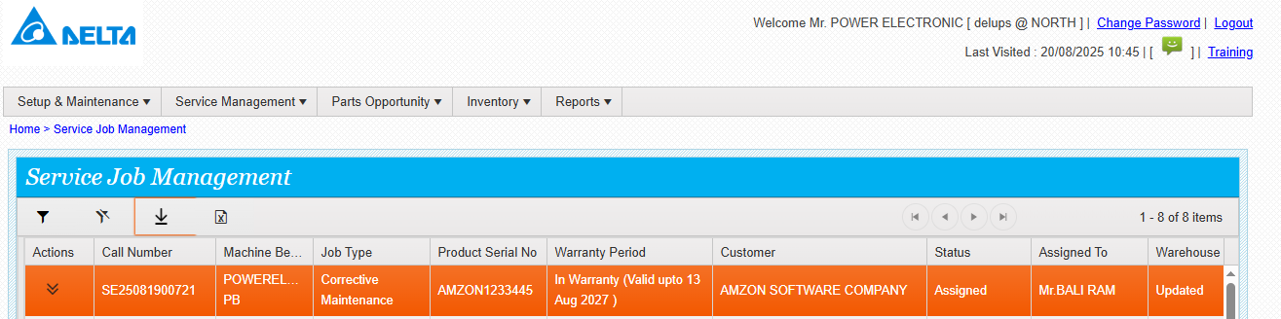

Engineer do the mobile login and do the steps.

1. Mobile login
2. Trip start and finish
3. Work start and finish
4. FSR filling
5. Enter the spares consumption along with failed part serial nos
6. Submit the spare return form
7. Call complete
8. Return trip and finish

Screen shots below.

MOBILE LOGIN HOME PAGE

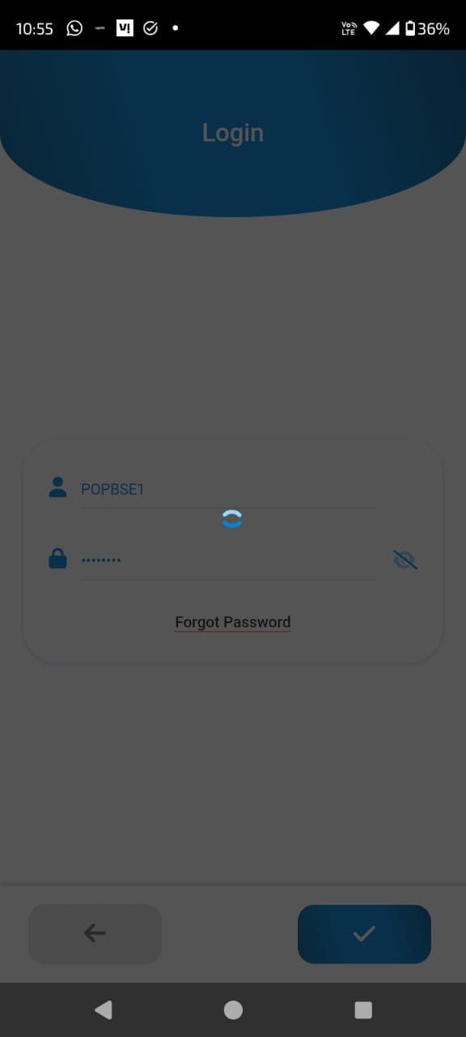 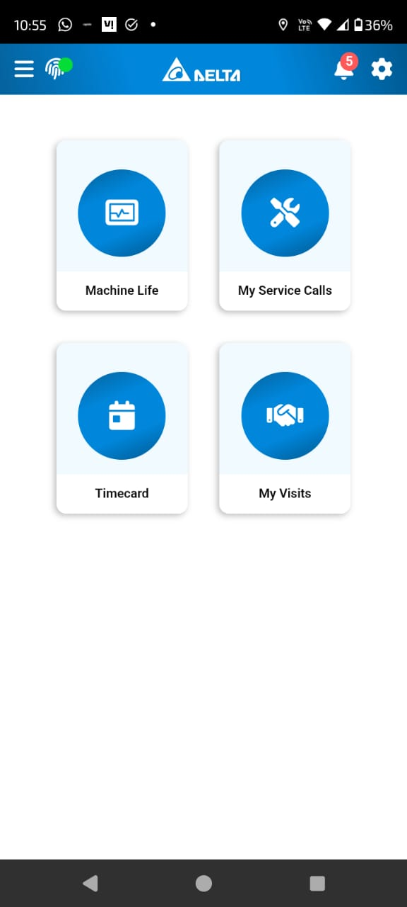

MY SERVICE CALLS TRIP START

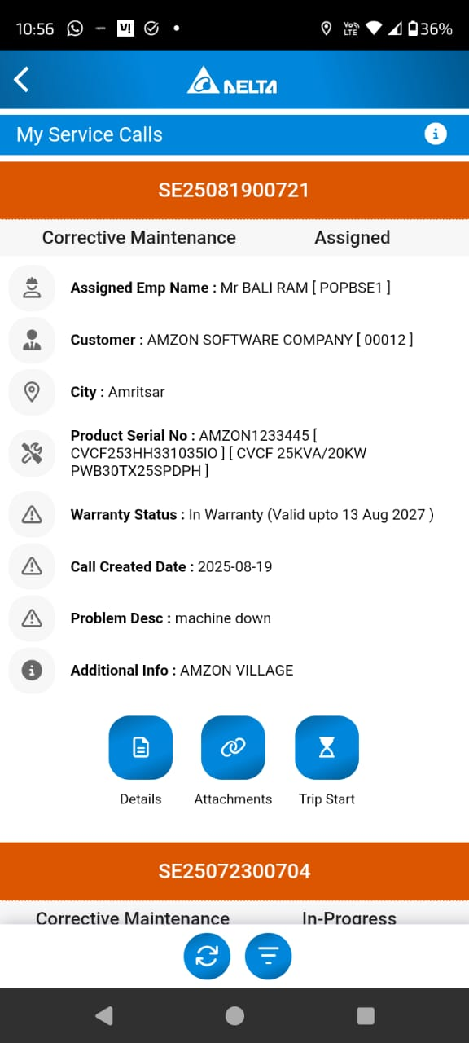 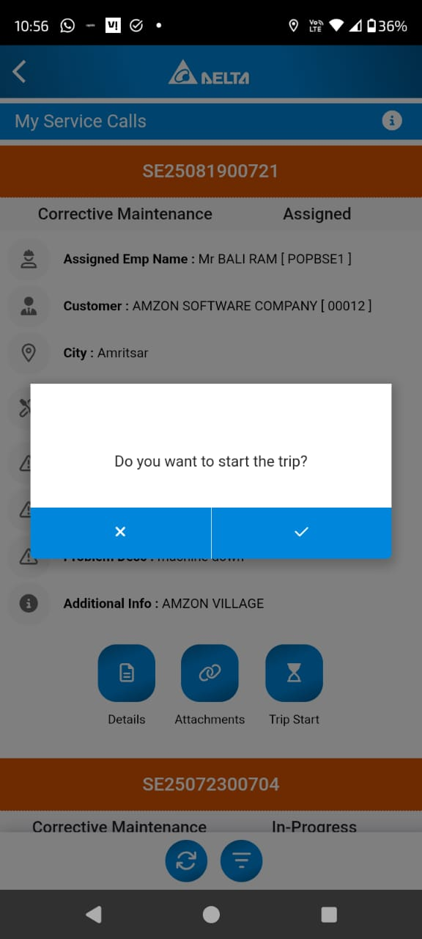

TRIP FINISH WORK START

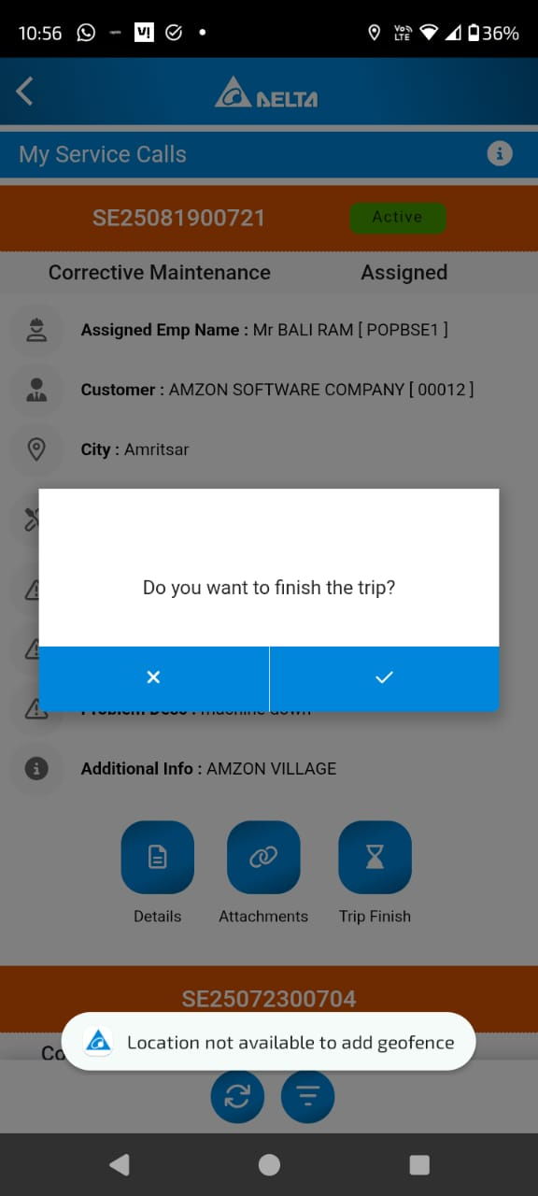 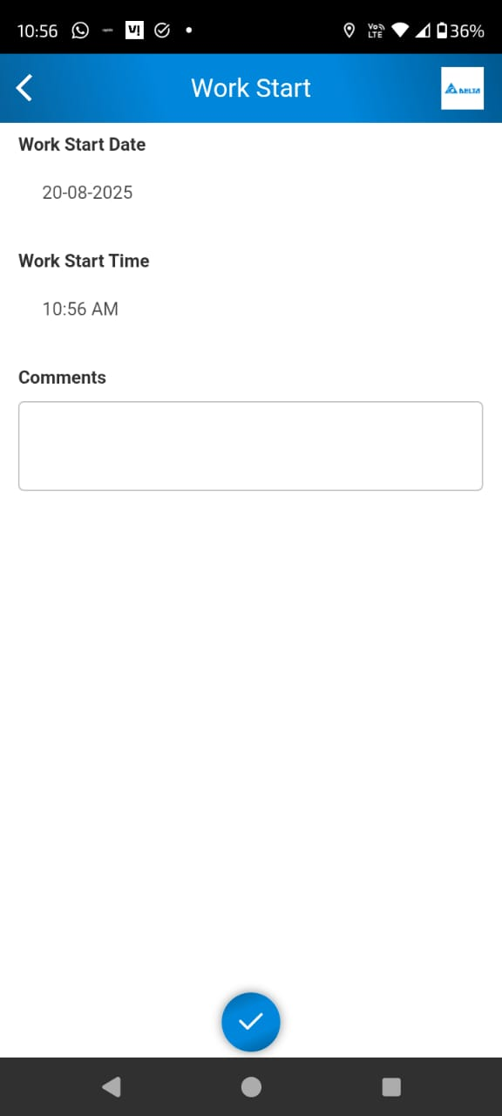

WORK FINISH CALL INPROGRESS

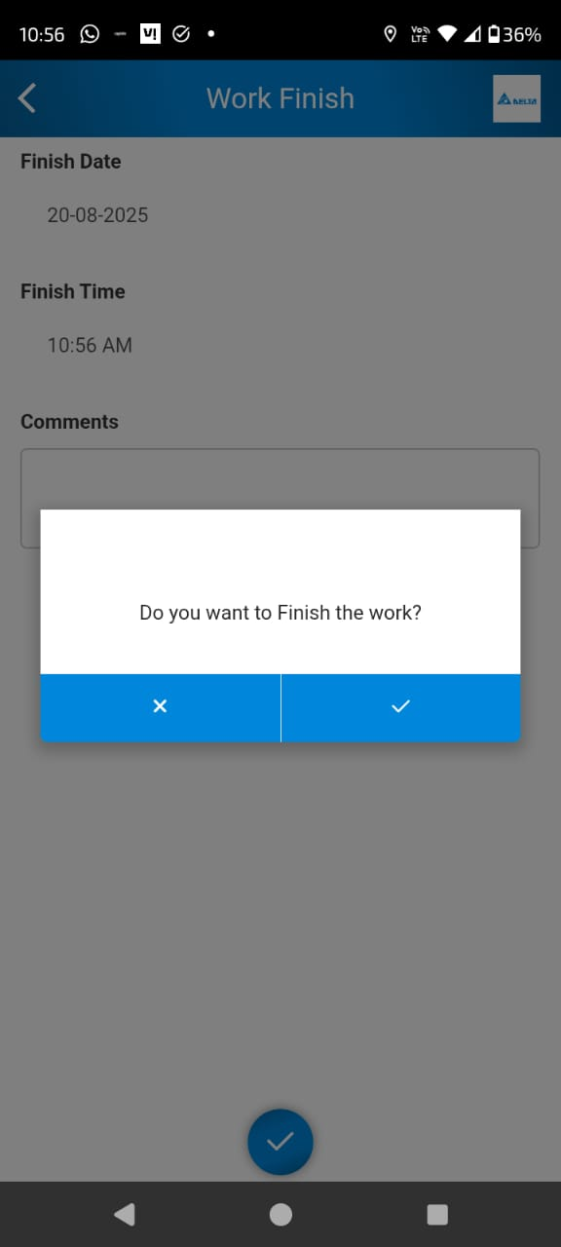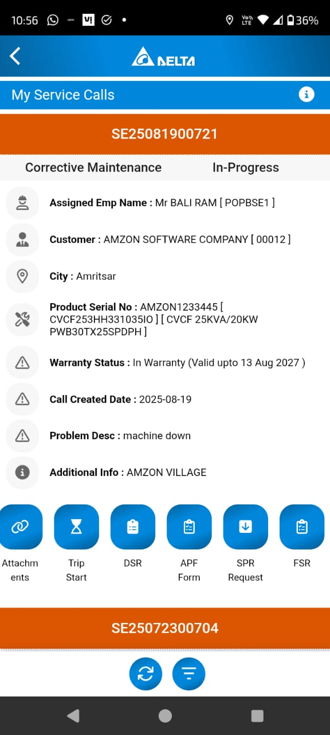

FSR SAPRE CONSUMPTION ENTRY

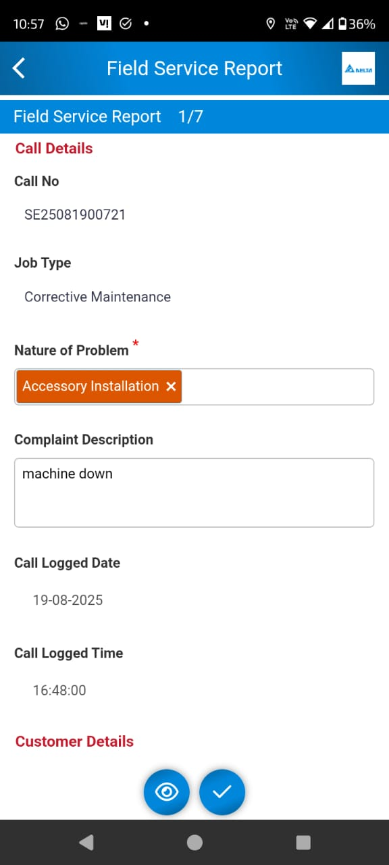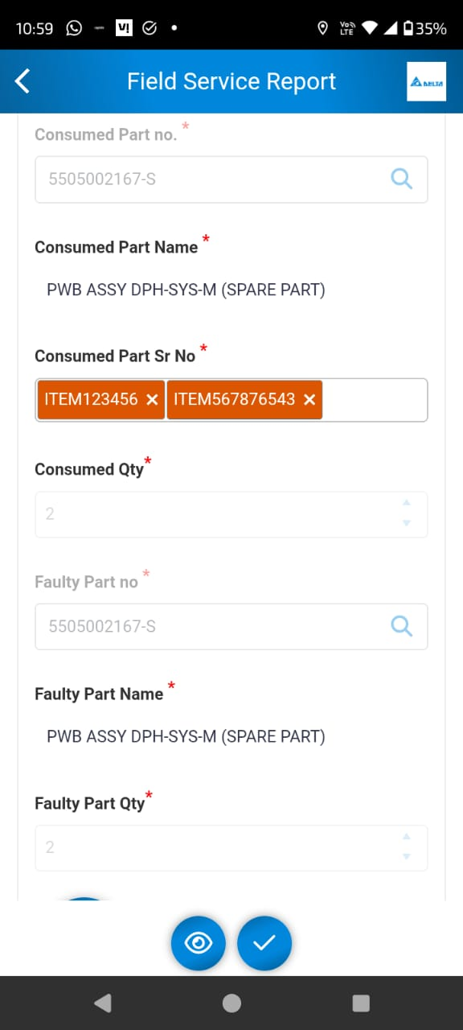

SPARE CONSUMED DETAILS FAULTY PARTS SERIAL NO ENTRY

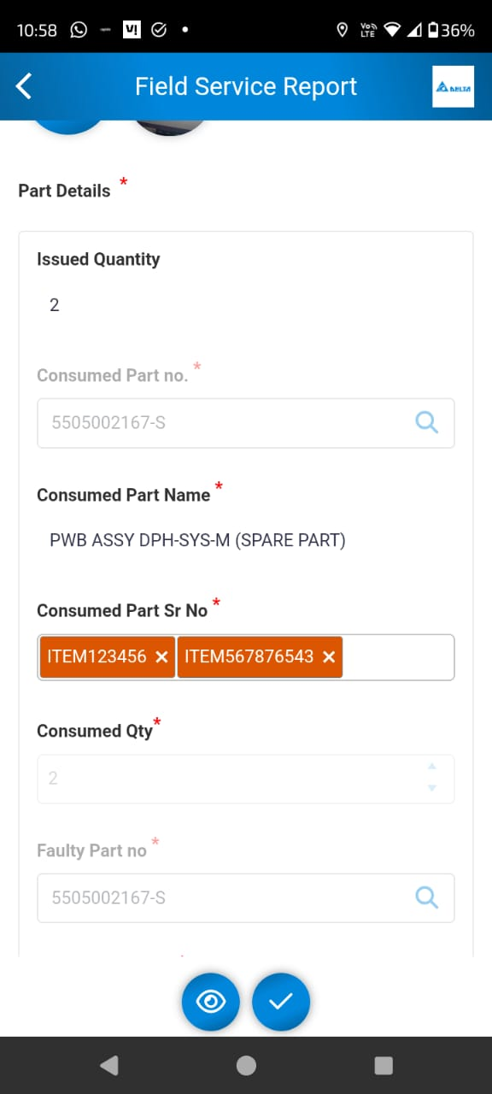 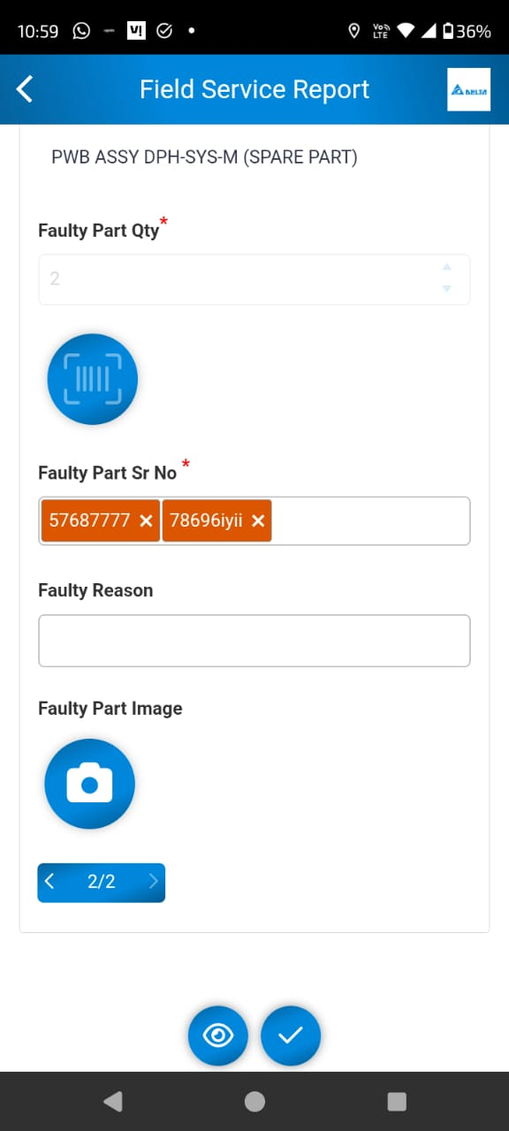

SPARE RETURN FORM SPARE RETURN FORM ENTRY

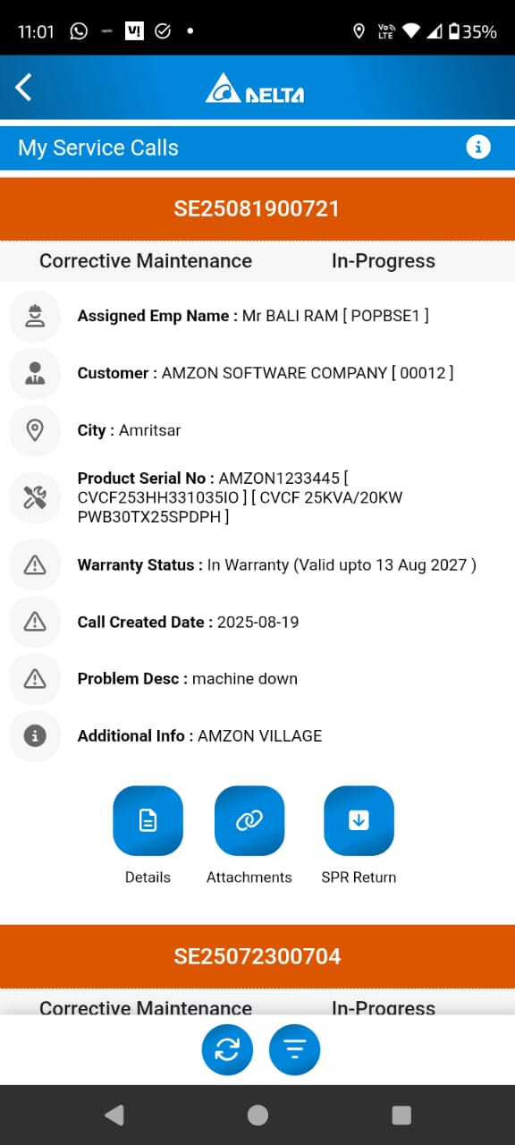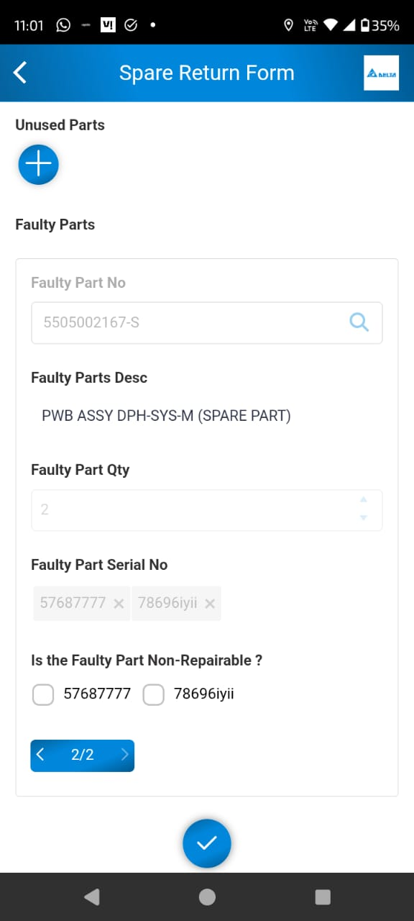

SPARE RETURN FORM SUBMIT CALL COMPLETE ACTION AVAIALBLE

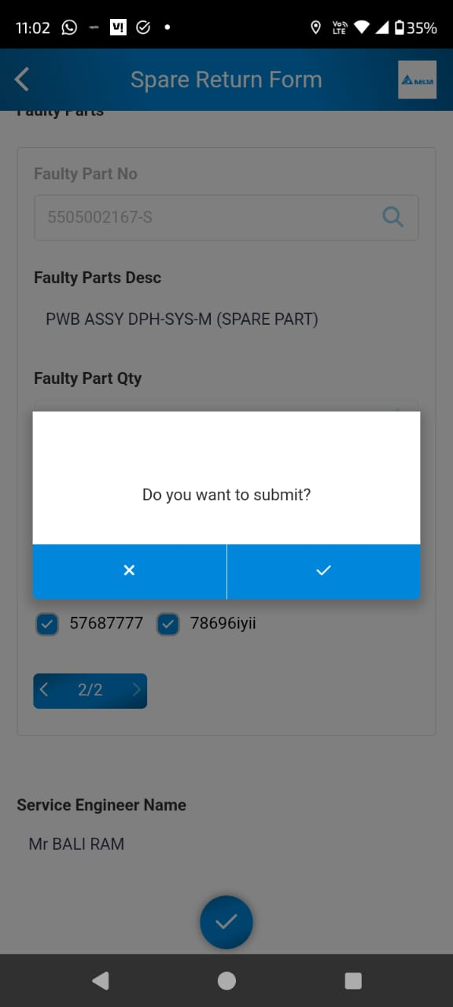 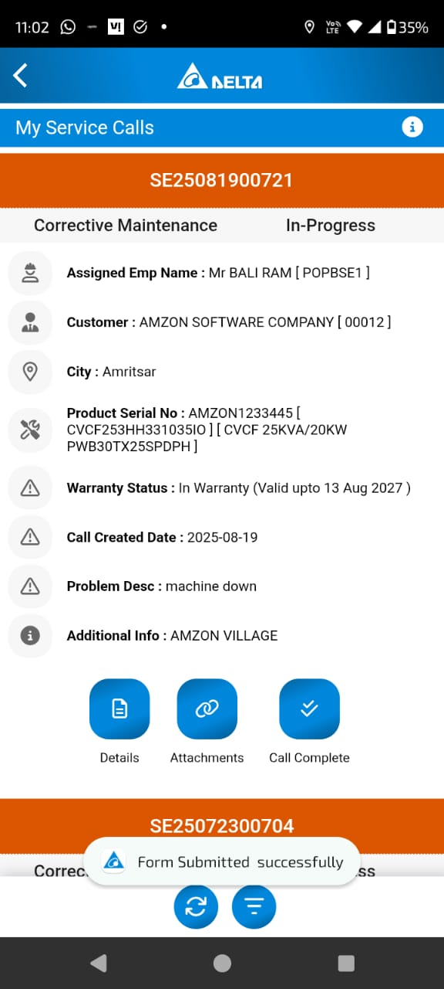

CALL COMPLETE RETURN TRIP START AND FINISH

